INFORMATION SYSTEMS III (Full-time)
2 HOURS MODULE B: DATABASE SYSTEMS 100 MARKS

QUESTION 1 (40 MARKS)

You have just been employed by the ROBCOR Trucking Company to develop a database. To gain a sense of the database’s intended functions, you have spent some time talking to ROBCOR’s employees and you’ve examined some of the forms used to track driver assignments and truck maintenance. Your notes include the following observations:
- Some drivers are qualified to drive more than one type of truck operated by ROBCOR. A driver may, therefore, be assigned to drive more than one truck during some period of time. ROBCOR operates several trucks of a given type. For example, ROBCOR operates two panel trucks, four .5 ton pick-up trucks, two single-axle dump trucks, one double-axle truck and one 16-wheel truck. A driver with a chauffeur’s license is qualified to drive only a panel truck and a .5-ton pick-up truck and may thus be assigned to drive any one of six trucks. A driver with a commercial license with an appropriate heavy equipment endorsement may be assigned to drive any of the nine trucks in the ROBCOR fleet. Each time a driver is assigned to drive a truck, an entry is made in a log containing the employee number, the truck identification, and the sign-out (departure) date. Upon the driver’s return, the log is updated to include the sign-in (return) date and the number of driver duty hours.
- If trucks require maintenance, a maintenance log is filled out. The maintenance log includes the date on which the truck was received by the maintenance crew. The truck cannot be released for service until the maintenance log release date has been entered and the log has been signed off by inspectors.
- All inspectors are qualified mechanics, but not all mechanics are qualified inspectors.
- Once the maintenance log entry has been made, the maintenance log number is transferred to a service log in which all service log transactions are entered. A single maintenance log number is transferred to a service log in which all service log transactions are entered. A single maintenance log entry can give rise to multiple log entries. For example, a truck might need an oil change as well as a fuel injector replacement, a brake adjustment, and a fender repair.
- Each service log entry is signed off by the mechanic who performed the work. To track the maintenance costs for each truck, the service log entries include the parts used and the time spent to install the part or to perform the service. (Not all service transactions involve parts. For example, adjusting a throttle linkage does not require the use of a part.)
- All employees are automatically covered by a standard health insurance policy. However, ROBCOR’s benefits include optional co-paid term life insurance and disability insurance. Employees may select both options, one, or none.

Given these brief notes, create the E-R diagram. Make sure you include all appropriate entities and relationships and define all connectivities, cardinalities and relationship participation.

Proposed Answer:
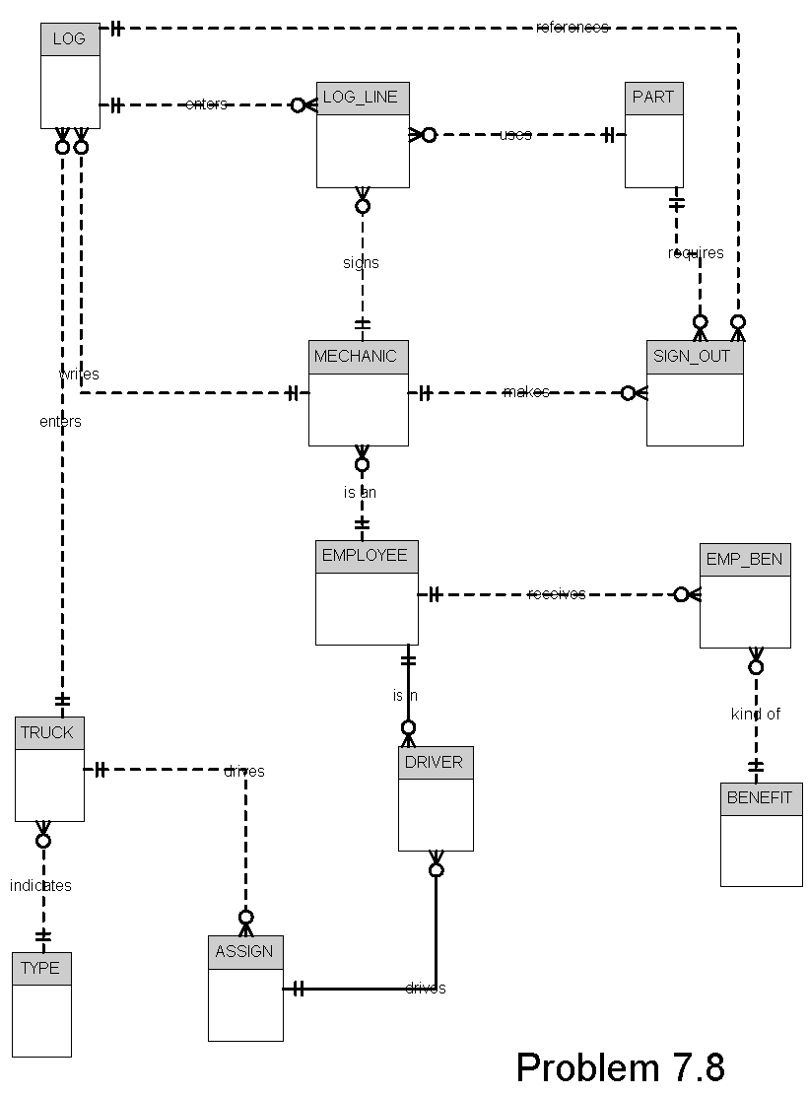

QUESTION 2 (10 MARKS)

In the early 1970s, the American National Standards Institute (ANSI) Standards Planning and Requirements Committee (SPARC) defined a framework for data modeling based on degrees of data abstraction.

Use a diagram to illustrate the various degrees of abstraction.

Proposed Answer

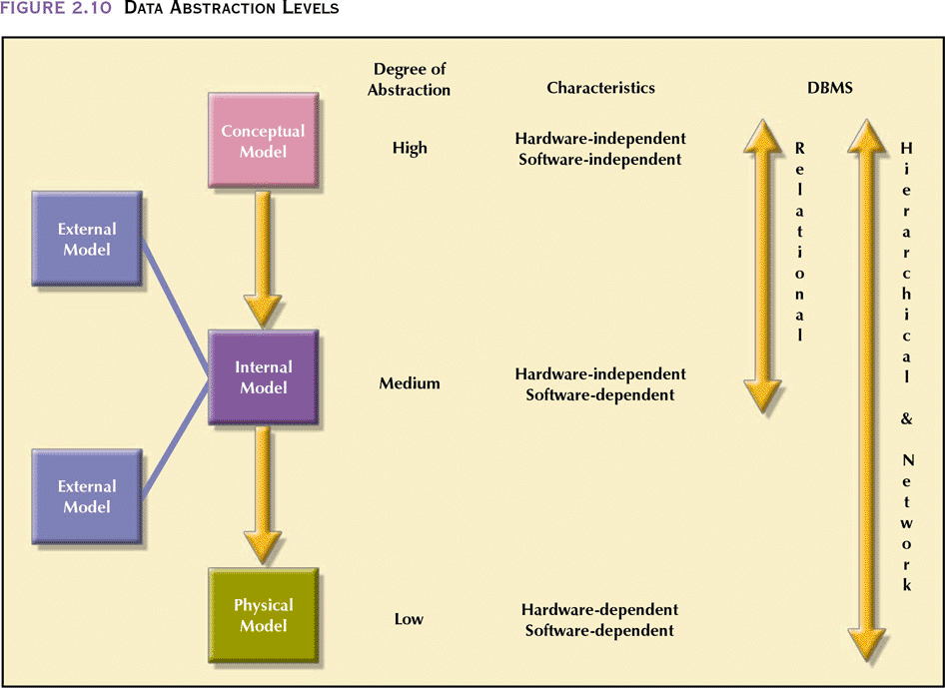

QUESTION 3 (5 MARKS)

What is the difference between a simple and single valued attribute? Give examples to motivate your answer.

Proposed Answer:
A single-valued attribute is an attribute that can only have a single value. E.g. ID Number. A simple attribute cannot be subdivided to yield additional attributes. E.g. Age. A single valued attribute is not necessarily a simple attribute. E.g. An ID Number is single-valued but composite.

QUESTION 4 (35 MARKS)

4.1 Concurrency control is important because the simultaneous execution of transactions over a shared database can create several data integrity and consistency problems. The three main problems are lost updates, uncommitted data, and inconsistent retrievals.

4.1.1 Use an example to explain the problem of lost updates. (6)
Proposed Answer:
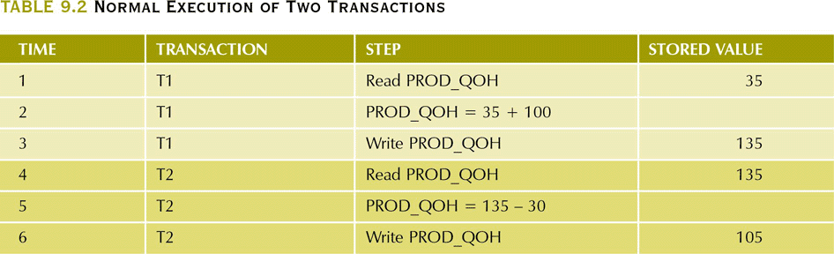

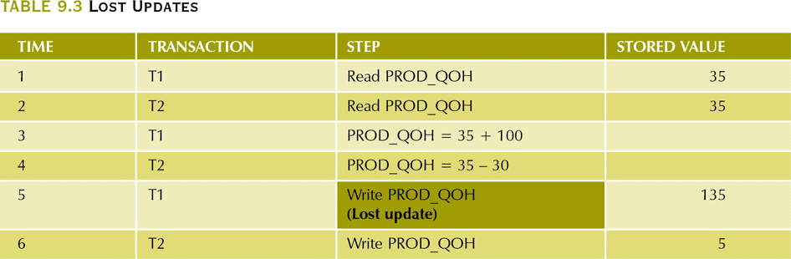

4.1.2 Use an example to explain the problem of uncommitted data. (6)
Proposed Answer:
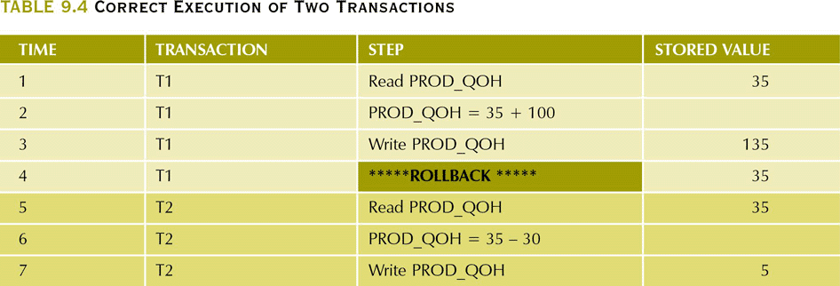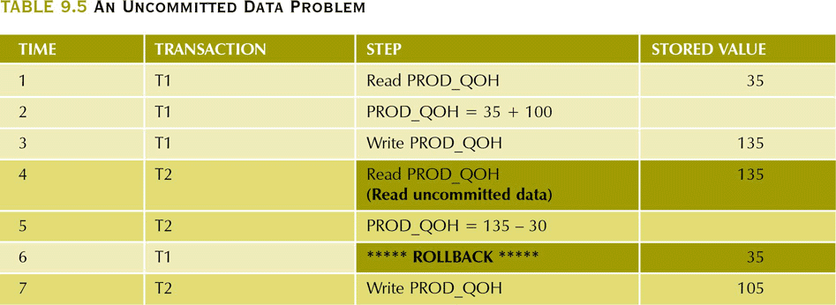

4.2 Use a diagram to explain the two-phase locking protocol. (6)
Proposed Answer:
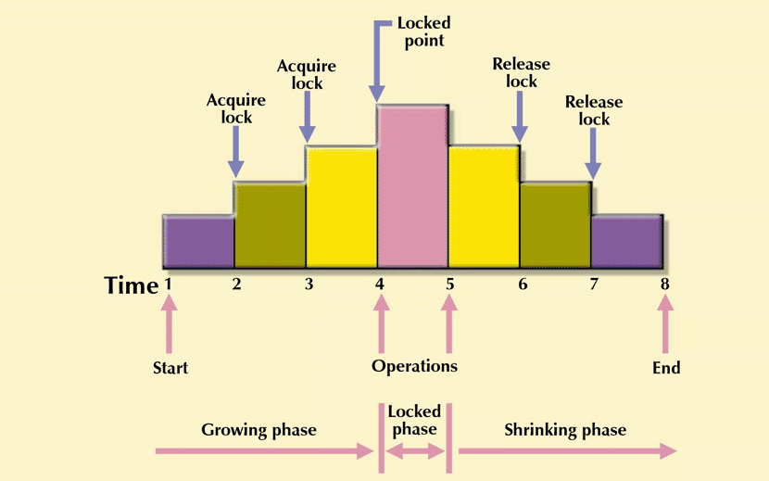

4.3 Within Microsoft Windows operating systems, whether PC based, like XP Pro or the Server editions, a backup and restore application is available for users. Within the application some of the options are Full, Incremental or Differential backups. Explain the difference between Full and Differential backup techniques. You may use a diagrammatic representation to give a clearer understanding. (6)
Proposed Answer:

Full
Full backup of the database is where a complete backup is made of the database or
dump of the database.

Differential
A differential backup of the database is where only the last modifications done to the
database (when compared with a previous backup copy) are copied.
A cumulative backup of all changes made after the last full backup. The advantage
to this is the quicker recovery time, requiring only a full backup and the latest
differential backup to restore the system. The disadvantage is that for each day
elapsed since the last full backup, more data needs to be backed up, especially if a
majority of the data has been changed.

Incremental
A "normal" incremental backup will only back up files that have been changed since
the last backup of any type. This provides the quickest means of backup, since it
only makes copies of files that have not yet been backed up. For instance, following
a full backup on Friday, Monday’s tape will contain only those files changed since
Friday. Tuesday’s tape contains only those files changed since Monday, and so on.
The downside to this is that in order to perform a full restore, one needs to restore
the last full backup first, followed by each of the subsequent incremental backups to
the present day in the correct order. Should any one of these backup copies be
damaged (particularly the full backup), the restore will be incomplete.

4.4 What is transaction isolation and why it is important? (4)
Proposed Answer:
Isolation means that the data used during the execution of a transaction cannot be used by a second transaction until the first one is completed. That is, if a transaction (T1) is being executed and is using data X, that data item cannot be accessed by another transaction until T1 is completed. This property is important in multiuser database environments because several different users can access and update the database at the same time.

4.5 Explain the transaction log, and what it is used for. (3)
Proposed Answer:
A DBMS uses a transaction log to keep track of all transactions that update the database. The information stored in the log is used by the DBMS for recovery requirements triggered by a rollback command, a program's abnormal termination, or a system failure such as a network discrepancy or a disk crash.

4.6 Explain the functions of shared and exclusive locks. (4)
Proposed Answer:
An exclusive lock exists when access is specifically reserved for the transaction that locked the object. This lock is used when the potential for conflict exists. On the other, hand the shared lock exists when concurrent transactions are granted read access on the basis of a common lock. A shared lock produces no conflict as long as the concurrent transactions are read-only.

QUESTION 5 (10 MARKS)

  - A ____ lock locks the entire disk page.
- a. | - transaction-level | - c. | - page-level
- b. | - table-level | - d. | - row-level
Answer: C

  - A ____ lock allows concurrent transactions to access different rows of the same table.
- a. | - database-level | - c. | - page-level
- b. | - table-level | - d. | - row-level
Answer: d
.

  - A(n) ____ specifically reserves access to the transaction that locked the object.
- a. | - shared lock | - c. | - binary lock
- b. | - exclusive lock | - d. | - deadlock
Answer: b

  - A(n) ____ lock exists when concurrent transactions are granted read access on the basis of a common lock.
- a. | - shared | - c. | - binary
- b. | - exclusive | - d. | - two-phase
Answer: a

  - A(n) ____ condition occurs when two transactions wait for each other to unlock data.
- a. | - deadlock | - c. | - binary lock
- b. | - exclusive lock | - d. | - two-phase lock
Answer: a

  - The most common algorithms for concurrency control are locks, ____ stamping, and optimistic methods.
- a. | - date | - c. | - hour
- b. | - time | - d. | - minute
Answer: b

  - ____ means that data used during the execution of a transaction cannot be used by a second transaction until the first one is completed.
- a. | - Serializability | - c. | - Isolation
- b. | - Atomicity | - d. | - Time stamping
Answer: c

  - When you read from and/or write to a database, you have created a(n) ____.
- a. | - transaction | - c. | - update
- b. | - back up | - d. | - queue
Answer: a

  - A(n) ____ backup of the data is when only the last modifications done to the database are copied.
- a. | - differential | - c. | - partial
- b. | - complete | - d. | - incomplete
Answer: a

  - The ____ approach is based on the assumption that the majority of the database operations do not conflict.
- a. | - default | - c. | - scheduled
- b. | - basic | - d. | - optimistic
Answer: d

